Assignment Submission Report
Name: Charles Taggart
Course / Cohort: FSDI-114 / 65
Assignment: Class_2.ipynb Assignment 2
GitHub Repository Link: https://github.com/chucktagg83/114-Algorithms.git

Evidence of Functionality

Frontend/UI
Attach 3 screenshots only:
- Main screen
- One interaction working
- One error state

Backend/Logic
- Adding in pop() and is_empty() to custom linked-list stack
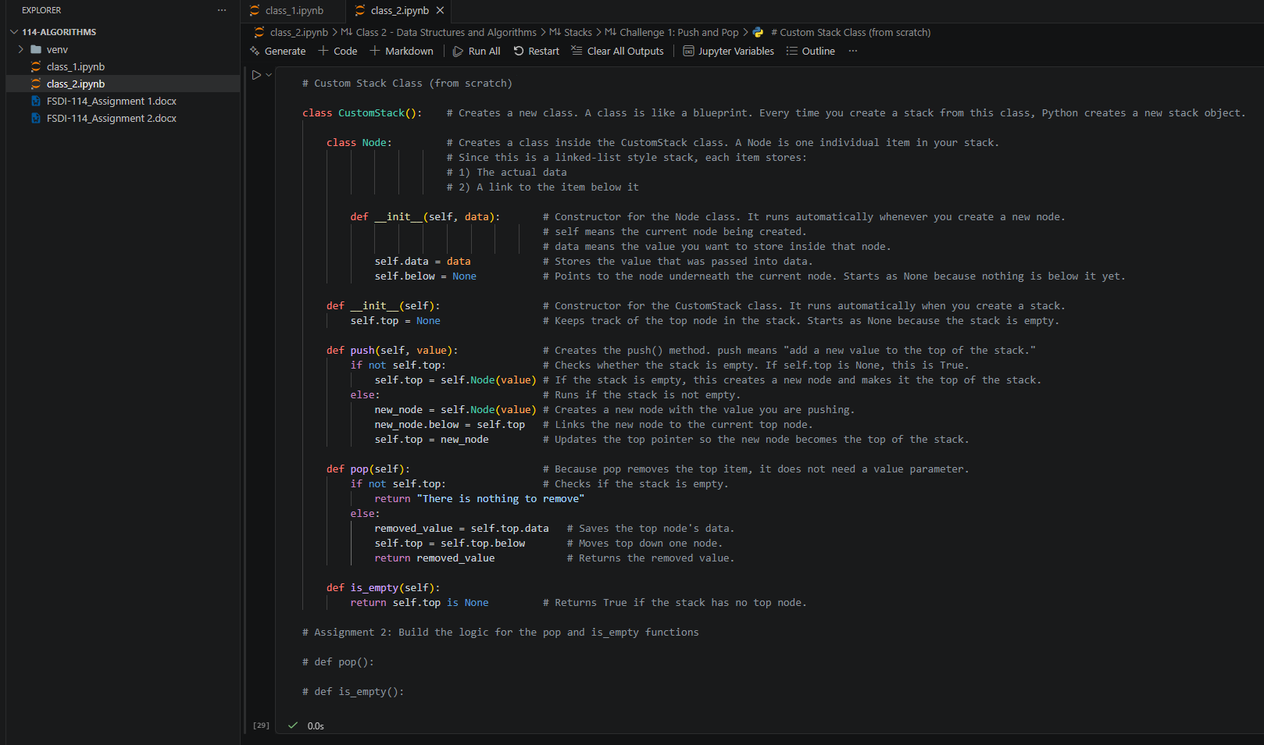

AI Disclosure (Required) – Highlight the one that applies
- I did not use AI
- I used AI for help
- AI generated parts of my code

